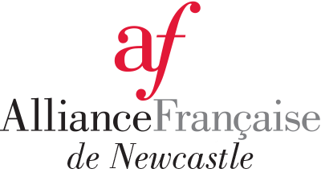

Creative Kids voucher FORM
We are very happy to let you know that the AF de Newcastle is now a registered and approved provider with Service NSW for the Creative kids voucher.
To obtain a rebate from the Alliance Française de Newcastle, you MUST complete the form below and return it to contact@afnewcastle.com.au before you register your child online.
Please, carefully read and fill in the following information

Full name of the parent or guardian: ………………………………………………………………………………………………………….

Email address of the parent or guardian: ………………………………………………………………………………………………………….

Phone number of the parent or guardian: ………………………………………………………………………………………………………….

Full name of the child (name of the child on the voucher) : ………………………………………………………………………………

Voucher number: ………………………………………………………………………………………………………….

DOB of the child on the voucher: ………………………………………………………………………………………………………….

The steps to redeem the Creative Kids voucher with the AF de Newcastle:
- Step 1: Apply for a Creative Kids voucher at Service NSW
- Step 2: Following receipt of your voucher number submit your voucher details to claim your redemption from the AF de Newcastle using this form. Make sure to return it to contact@afnewcastle.com.au before you register your child.
- Step 3: The AF de Newcastle will process the voucher with Service NSW. Following validation of your voucher, the AF de N will send you an email to confirm the validation of the voucher and the creation of the credit under the name of your child.
- Step 4: You can register your child for the French classes on the website. The credit will be allocated within our online system (under the name of your child) and it should be automatically applied at the moment of paying when you register your child. If it does not work, please let us know before you enrol.
- Thank you

